**COMMUNICATION USING RETROFIT**

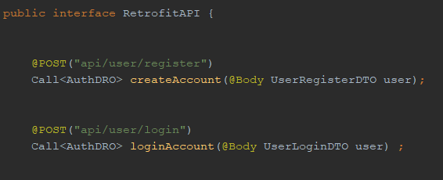

Class responsible for handling connection is **RetrofitAPI** interface. Thanks to Retrofit, HTTP API is turn into JAVA interface where http methods are defined. Both methods are taking a dummy object in the parameter which is sent through Retrofit.

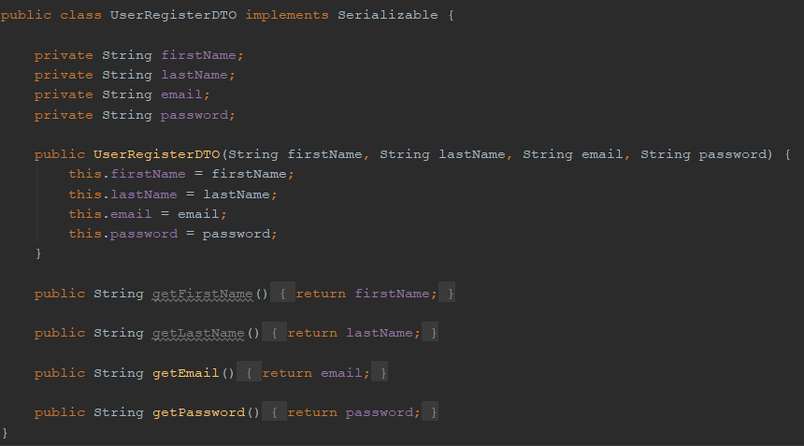

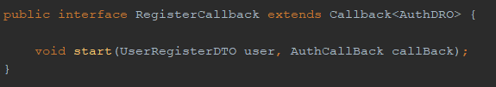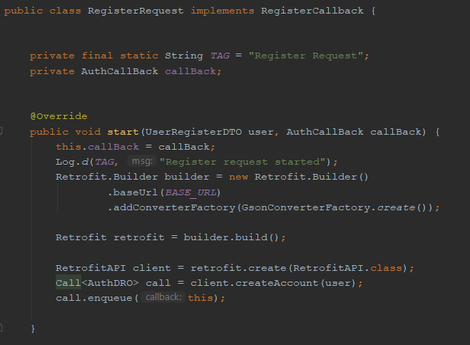Request classes are responsible for a Retrofit configuration. Both of them are implementing Callback Interface to react to a Retrofit response. Callback is type of AuthDRO, a dummy read object which is returning status code and userID. ***onResposnse*** method a status code is checked and depending on result an action is taken.

In **RegisterRequest** ***onReturn method*** is executed in order to pass authDRO to **RegisterViewModel** and set ***isRegister*** to true which opens a new activity after successful registering.

